**Ultimate Guide to Passing the HAAD Exam: Your Path to Medical Licensing in Abu Dhabi**

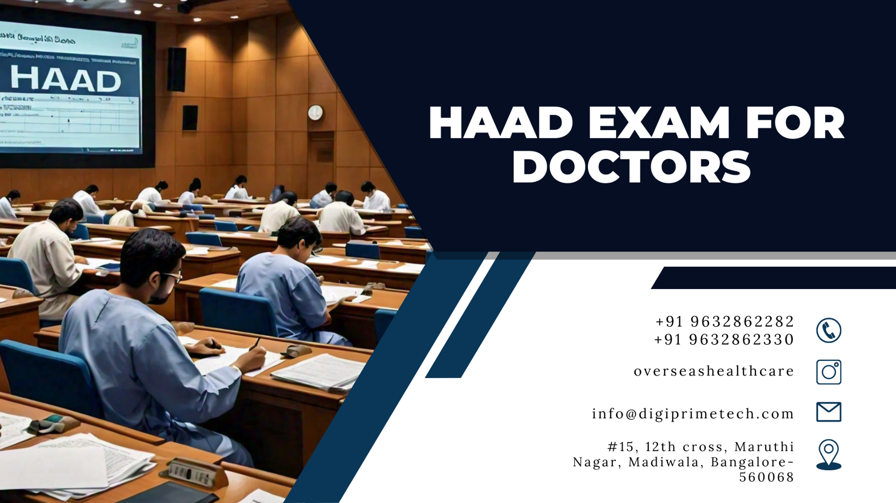

A vital prerequisite for medical professionals hoping to work in Abu Dhabi's healthcare system is passing the Health Authority of Abu Dhabi (HAAD) Exam. If you intend to take the test, you may find the procedure much easier if you know what to expect and have professional assistance. Healthcare practitioners who need assistance passing the HAAD exam and obtaining medical licensure can turn to Digit PrimeTech and Overseas Healthcare Consultant.

This blog post will cover all the information you require to take the HAAD exam, as well as how Digit PrimeTech and Overseas Healthcare Consultant can help you along the way.

**1. Describe the HAAD Exam.**

The HAAD exam verifies that medical practitioners, including physicians, nurses, and allied health personnel, fulfill the prerequisites to practice in Abu Dhabi. You can only practice in the area if you pass this exam and obtain the HAAD license.

**2. Who Must Take the HAAD Test?**

Many different types of healthcare workers must pass the HAAD exam, including:

Physicians (Physicians and Associates)

* Nurses (both Specialized and Registered)
* Chemists
* Dental professionals
* Physiotherapists
* Laboratory Technicians
* Additional Allied Health Professionals

**3. Qualification Standards for the HAAD Assessment**

You have to fulfill some requirements in order to apply for the HAAD exam, like:

a degree that is respected in your field of study.

* two to three years' worth of minimal relevant work experience.
* certificates from prior employers attesting to their excellent standing.
* Certain professions could need additional certificates.
* To make sure you are eligible, Digit PrimeTech and Overseas Healthcare Consultant can help you with these needs.

**4. HAAD Exam Enrollment Procedure**

The following are the primary procedures for HAAD exam registration:

Step 1: Verification of Data Flow

Finishing the Primary Source Verification (PSV) via DataFlow is the first stage. This validates your credentials, employment history, and education.

Step 2: Fill out an online application

You can submit an online application for the HAAD exam once DataFlow is finished.

**5. HAAD Test Structure**

A computer-based test with multiple-choice questions (MCQs) makes up the HAAD exam. Depending on your area of expertise, the format and content will vary, but the test often covers:

clinical expertise

* Useful abilities
* Management of patient care
* Depending on the occupation, different passing scores apply, thus it's critical to study well.

**6. Advice for HAAD Exam Readiness**

Examine the official syllabus for your specialization by studying the HAAD Syllabus.

* Make Use of Reputable Study Materials**:** Go for credible web resources and study guides.
* Practice Exams: Getting accustomed to the exam format can be achieved by regular practice.
* Enroll in Coaching Programs: To make sure you are ready, Digit PrimeTech and Overseas Healthcare Consultant both offer structured preparation programs.

**7. What Takes Place Following the HAAD Exam?**

You'll get your results from the HAAD exam in a few days after you finish it. You can then apply for your HAAD license if you are approved. After a waiting period, you can retake the exam if you don't pass.

**8. How Digit PrimeTech and Overseas Healthcare Consultants Can Help**

While getting ready for the HAAD exam can be difficult, Digit PrimeTech and Overseas Healthcare Consultant are here to support you every step of the way. Among their offerings are:

* support for HAAD exam registration and DataFlow verification.
* Professional guidance on study techniques and resources for exams.
* assistance with the application and paperwork procedures.
* a committed staff to address your inquiries and guarantee a seamless encounter.
* By offering individualized assistance,

**In summary**

In order to practice in Abu Dhabi, healthcare practitioners must pass the HAAD test. You may pass the exam and get your HAAD license with the correct preparation and direction from Digit PrimeTech and Overseas Healthcare Consultant, opening doors to a fulfilling healthcare profession in the United Arab Emirates.

Are you prepared to go off on your journey? For professional help reaching your career objectives in healthcare, get in touch with Digit PrimeTech or Overseas Healthcare Consultant!

To Learn More Visit:[**HAAD EXAM FOR DOCTORS**](https://www.overseashealthcareconsultant.com/haad-exam/)